Earthquakes and Seismic Waves

Introduction
An earthquake is the shaking and trembling that results from the movement of rock beneath Earth's surface. The point beneath Earth's surface where rock under stress breaks to cause an earthquake is called the focus. The point on the surface directly above the focus is called the epicentre.
During an earthquake, vibrations called seismic waves move out from the focus in all directions. Seismic waves carry the energy of an earthquake away from the focus, through Earth's interior, and across the surface.
There are three categories of seismic waves: P waves, S waves, and surface waves. P waves compress and expand the ground like an accordion. S waves vibrate from side to side and up and down. When P waves and S waves reach the surface, some become surface waves. Surface waves move more slowly than P waves and S waves.
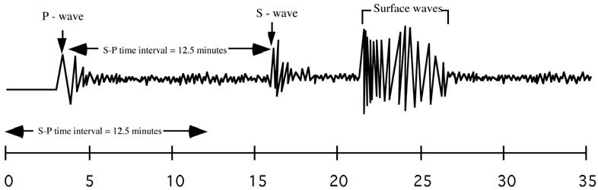
Geologists use seismic waves to locate an earthquake's epicentre. The seismic waves can be measured by a seismograph. When an earthquake strikes, P waves arrive at a seismograph first and S waves next (the surface waves arrive last).

The time difference between the P and the S waves tells scientists how far from the seismograph the epicentre is. The further apart the P and S waves, the further away the earthquake is. But knowing how far away the earthquake is does NOT tell you which direction it was. So, scientists use three different seismograph stations to triangulate a position in a map. This means that three seismograph reading must be used to identify where an earthquake occurred.
An earthquake's magnitude is a number that geologists assign to an earthquake based on the earthquake's strength. The Richter scale is a rating of an earthquake's magnitude based on the size of the earthquake's seismic waves. The size of the seimic waves can be measured of the seismograph, and used with distance measurements to estimate the magnitude of the earthquake. An earthquake's magnitude tells geologists how much energy was released by the earthquake. The effects of an earthquake increase with magnitude.
QUESTIONS

- The point underneath the surface of the earth, at which a rock under stress breaks and triggers an earthquake is called the
- The point on the surface directly above the focus is the
3. What are seismic waves?
- Is the following sentence true or false? Seismic waves carry the energy of an earthquake away from the focus in all directions.
- Circle the letter of each term that is a category of seismic wave.
  - P wave
  - S wave
  - surface wave
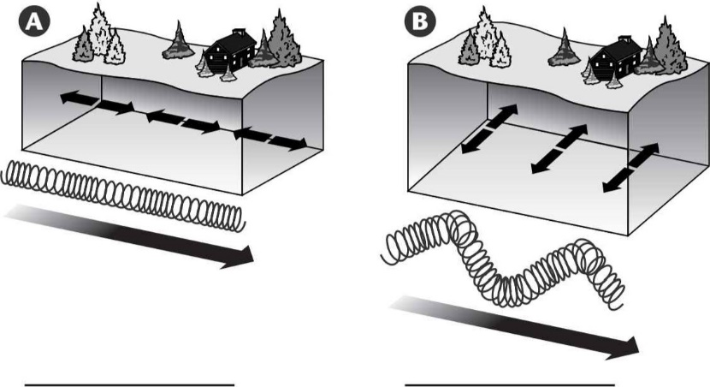
  - underground wave
- Label each drawing as S Waves or P Waves.

- Is the following sentence true or false? Surface waves move more quickly than P waves and S waves.
8. A device that records the ground movements caused by seismic waves is a(n)
- Is the following sentence true or false? The closer an earthquake, the greater the time between the arrival of P waves and the arrival of S waves.
- How do geologists locate the epicenter of an earthquake?

Finding the Epicentre
How can you locate an earthquake's epicentre?
STEP 1
You need three seismograph readings showing the P and S waves. For each seismograph draw a line where the very first P waves, and the very first S waves were. Then, by looking at the times, calculate the time between the P wave line and the S wave line. This is the S-P wave time difference. Do this for all three seismographs.
STEP 2
For step 2 you need a graph of S_P time difference versus distance (see later on in this doc). On this graph you convert all three S_P time difference (from step 1) into distances. So you now have a distance for each seismograph.
STEP 3
For step 3 you need a map showing the location of all three seismographs (they are usually in major cities). Using a compass, draw a circle around each seismograph to represent the distance the earthquake is from each seismograph. This is the simplest step, but hard to explain, so your teacher may show you how to do this.
STEP 4
Identify where all three circles cross over each other – label this the epicentre.

Example – this has some of the steps done for you.
An earthquake occurred somewhere in America. Seismographs in three different cities in America recorded the seismic waves.

- Step 1 has already been completed (the S-P time difference was calculated from the seimographs) and recoded in the table below.

City | S-P time difference (seconds)
Denver, Colorado | 110 sec
Houston, Texas | 170 s
Miami, Florida | 260 s

- Step 2 has partially been done for you. The graph on the next page has been used to convert the times into distances for one of the cities. You do this for the other two
Graph for converting S-P time difference into distance to epicentre.
Distance to epicentre (km)
S-P time difference (s)

City | S-P time difference (secs) | Distance to Epicentre (km)
Denver, Colorado | 110 s | 1200 km
Houston, Texas | 170 s | _____ km
Miami, Florida | 260 s | _____ km

- Step 3 has also partially been done for you. Use a compass to measure out each of the “distance to epicentre” values. For each value, draw a circle out from the city where that seismograph is located.
For example – a compass was set at 1200km using the scale at the top, and then this was used to draw a circle around Denver (where that seismograph was).
Do the same for the other two values, belonging to Houston and Miami.

- Step 4 – put a cross in the centre of where the circles all overlap.Label this the epicentre! You are done!.
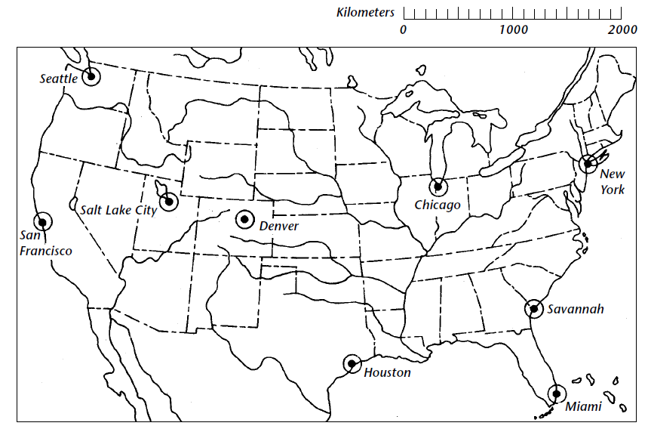
3000
4000

TASK – Try completing the same four steps for the following data
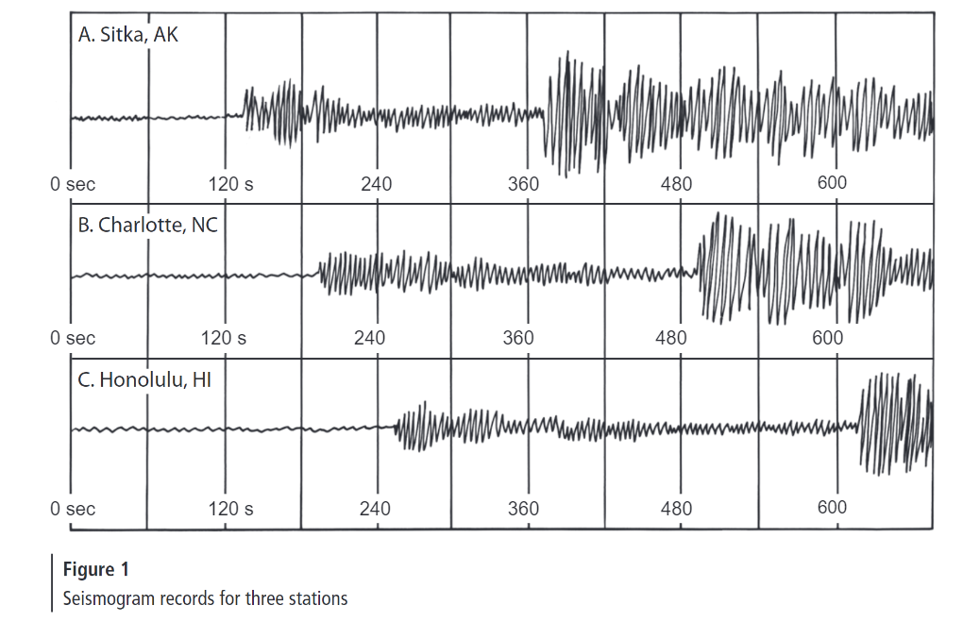
720
720
720

Distance to epicentre (km)
S-P time difference (s)
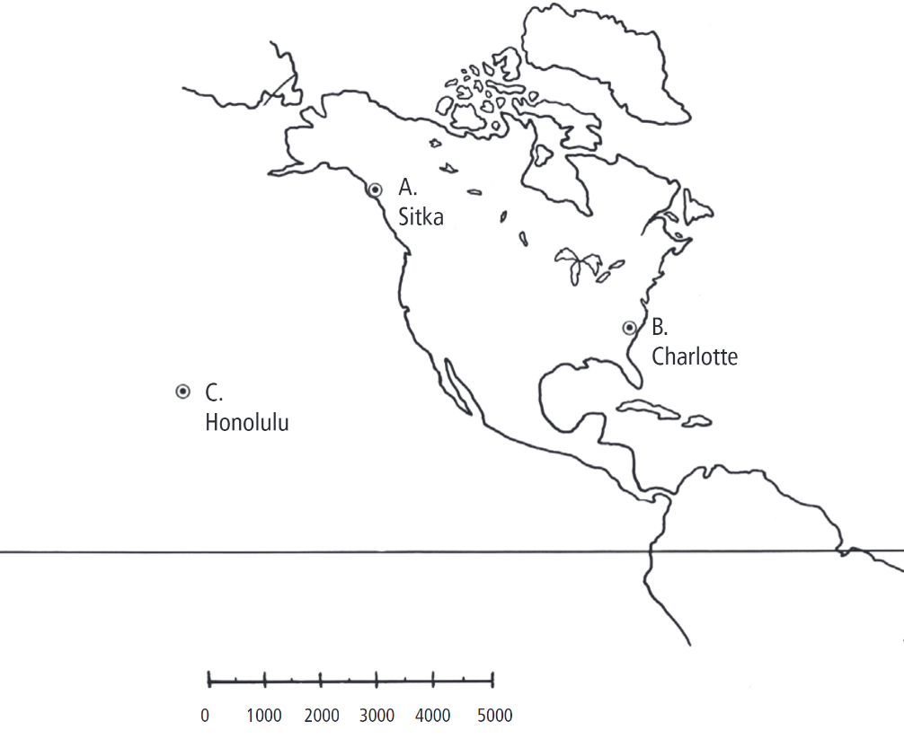
Equator

